**ShopEZ: One-Stop Shop for Online Purchases**

**PROJECT REPORT**

**1. INTRODUCTION**

**1.1 Project Overview**

The project titled **"ShopEZ – One-Stop Shop for Online Purchases"** aims to empower local shopkeepers by providing a digital platform to showcase and sell their products online. The system allows sellers to register, manage their products and orders, while customers can browse, search, and securely purchase items. Admins monitor all platform activities.  
ShopEZ helps bridge the gap between offline small businesses and the digital marketplace by eliminating the need for high-cost third-party platforms and complex technologies.

**1.2 Purpose**

The purpose of this project is to provide an affordable, scalable, and user-friendly platform that connects small businesses with customers looking for local products. It ensures:

* Easy digital store setup for sellers
* Smooth, secure shopping experience for buyers
* Transparent order tracking
* Direct support of local commerce

**2. IDEATION PHASE**

**2.1 Problem Statement**

Small shopkeepers lack technical expertise and affordable tools to sell products online. Customers struggle to find and trust local sellers on large marketplaces.

How Might We:

How might we help local sellers and customers connect through a simple, affordable, and reliable e-commerce platform?

**2.2 Empathy Map Canvas**

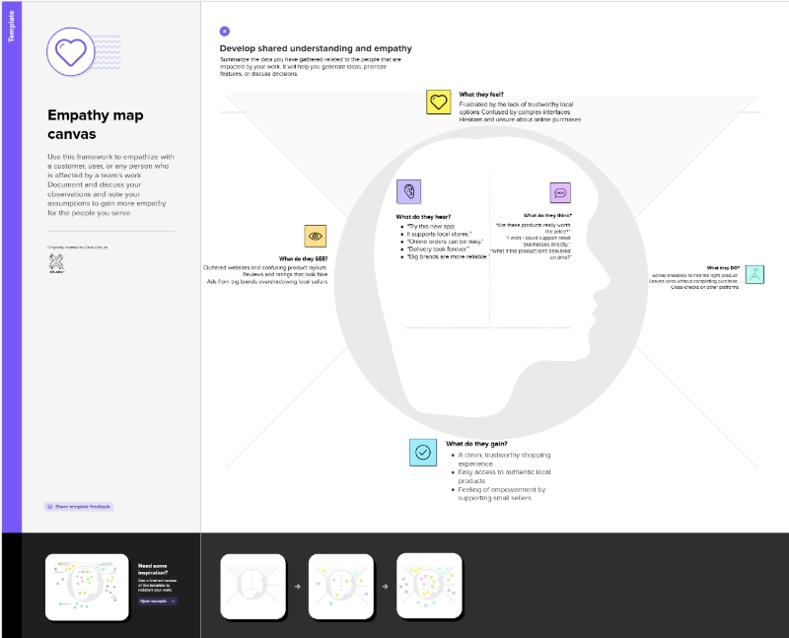

Says:

“I wish I could sell my products online without paying huge commissions.”

Thinks:

“Will customers trust a small local shop?”

Feels:

Overwhelmed, excluded from digital growth

Does:

Manages inventory manually, relies on word-of-mouth

**2.3 Brainstorming**

During the brainstorming session, the team explored ideas such as:

* No-code store setup
* Commission-free model for small vendors
* Real-time order tracking
* Seller dashboard with inventory analytics
* Integration with WhatsApp and local delivery

**3. REQUIREMENT ANALYSIS**

**3.1 Customer Journey Map**

The customer journey includes the following key stages:

• Awareness: Learns about ShopEZ

• Signup/Login: Creates account

• Search & Filter: Browses by product type, category

• Add to Cart & Checkout: Selects product, pays securely

• Order Tracking: Receives updates

• Delivery & Review: Confirms order and leaves feedback

**3.2 Solution Requirements**

Functional Requirements:

* Customer & Seller Registration/Login
* Product Listing, Editing & Deletion (Seller)
* Product Search & Filter (Customer)
* Add to Cart, Checkout & Payment
* Order Management Dashboard
* Admin Approval for Sellers
* Notifications via Email/SMS
* Review & Rating System

Non-Functional Requirements:

* Fast load time (<2 seconds)
* JWT-based secure authentication
* Responsive design for all devices
* 99.9% uptime guarantee
* Scalable to support thousands of users

**3.3 Data Flow Diagram**

**External Entities:** Customer, Seller, Admin  
**Processes:** Registration/Login, Product Management, Cart & Checkout, Admin Review  
**Data Stores:** Users DB, Product DB, Order DB, Payments DB

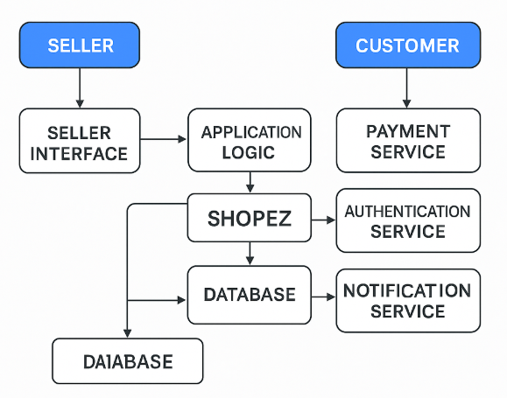

**3.4 Technology Stack**

**Frontend:** React.js (web) **Backend:** Node.js with Express.js  
**Database:** MongoDB (NoSQL) **Authentication:** JWT **Hosting:** Vercel (Frontend), Render (Backend), MongoDB Atlas (Database)  
**Other Services:** Stripe for payment, Cloudinary for images

**4. PROJECT DESIGN**

**4.1 Problem-Solution Fit**

This platform directly addresses seller affordability and accessibility while solving buyer trust and convenience by offering a clean, reliable, and secure experience.

**4.2 Proposed Solution**

A scalar web app where:

• Sellers can list/manage products and view orders

• Customers can browse, order, and track deliveries

• Admins can verify sellers and monitor system health

**4.3 Solution Architecture**

**Architecture Type**: Client-Server (MERN Stack)

**Presentation Layer:** React.js

**Business Logic Layer:** Node.js APIs

**Data Layer:** MongoDB + Cloud Storage

**5. PROJECT PLANNING & SCHEDULING**

**5.1 Project Planning**

| **Sprint** | **Duration** | **Tasks** |
| --- | --- | --- |
| Sprint-1 | 16–18 June 2025 | Environment setup, basic UI, routing |
| Sprint-2 | 19–20 June 2025 | Auth system for customer and seller |
| Sprint-3 | 21–23 June 2025 | Product management, search, filter |
| Sprint-4 | 24–26 June 2025 | Cart, payment, order flow, testing |

**6. FUNCTIONAL AND PERFORMANCE TESTING**

**6.1 Performance Testing**

**Tools Used**:

* Postman (API testing)
* JMeter (Load testing)

**Scenarios:**

* Simulated 100+ concurrent users
* Measured API response time (<1.2 sec)
* Tested database performance under load

**Results**:

* All modules passed stress testing
* No significant delays or timeouts

**7. RESULTS**

**7.1 Output Screenshots**:

**HOME PAGE:**

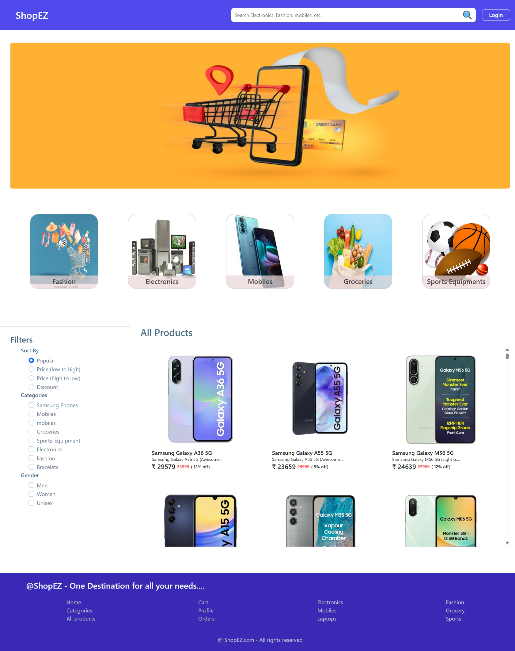

**LOGIN PAGE:**

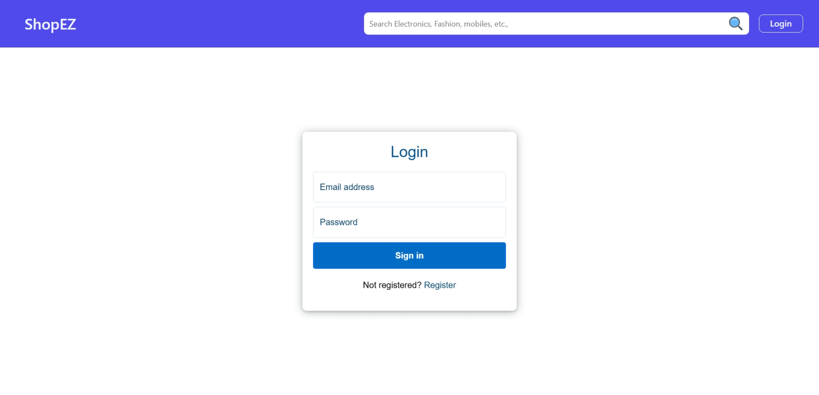

**REGISTER PAGE:**

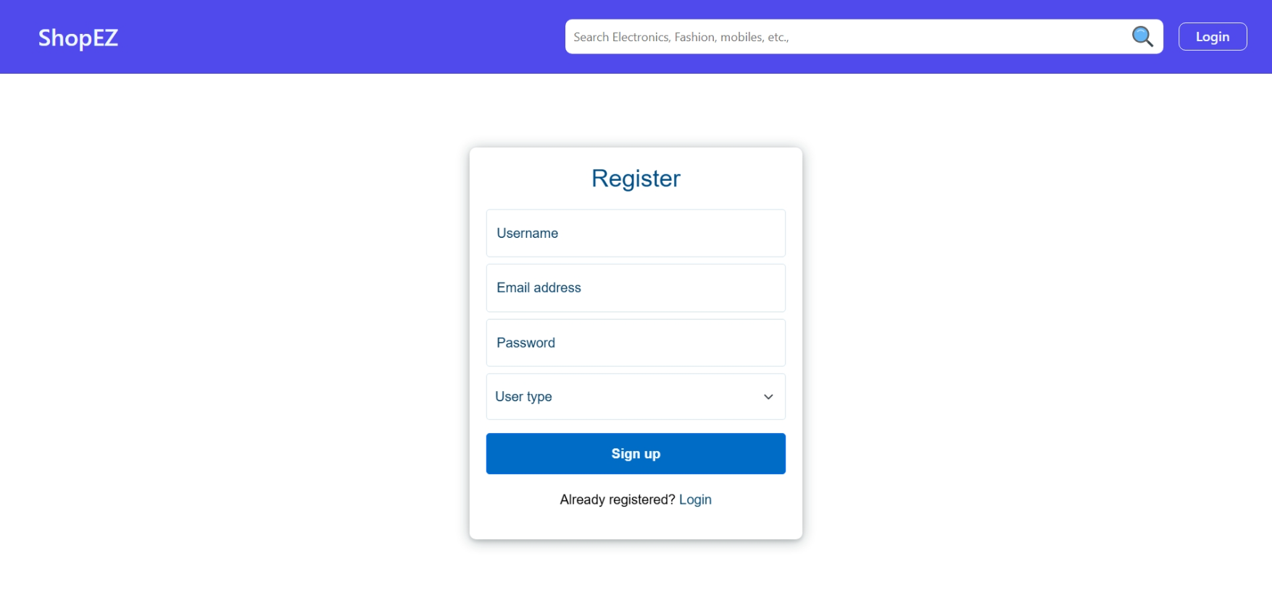

**PROFILE PAGE(USER):**

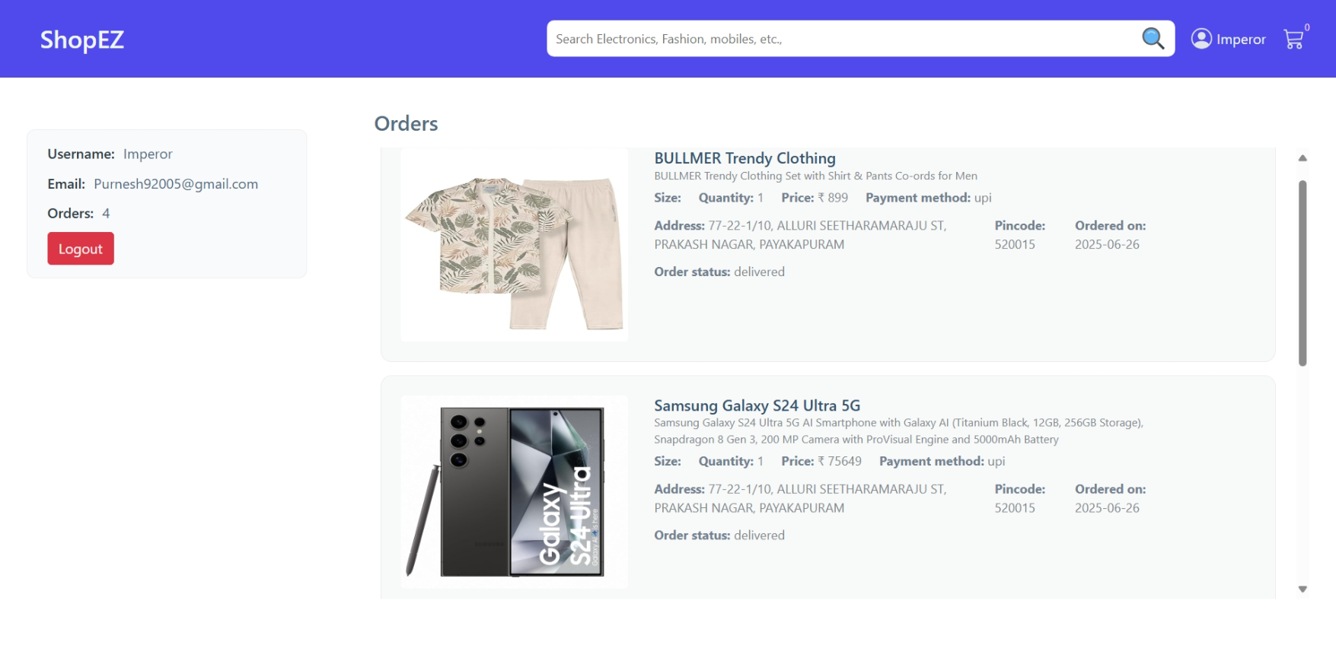

**ADMIN PAGE:**

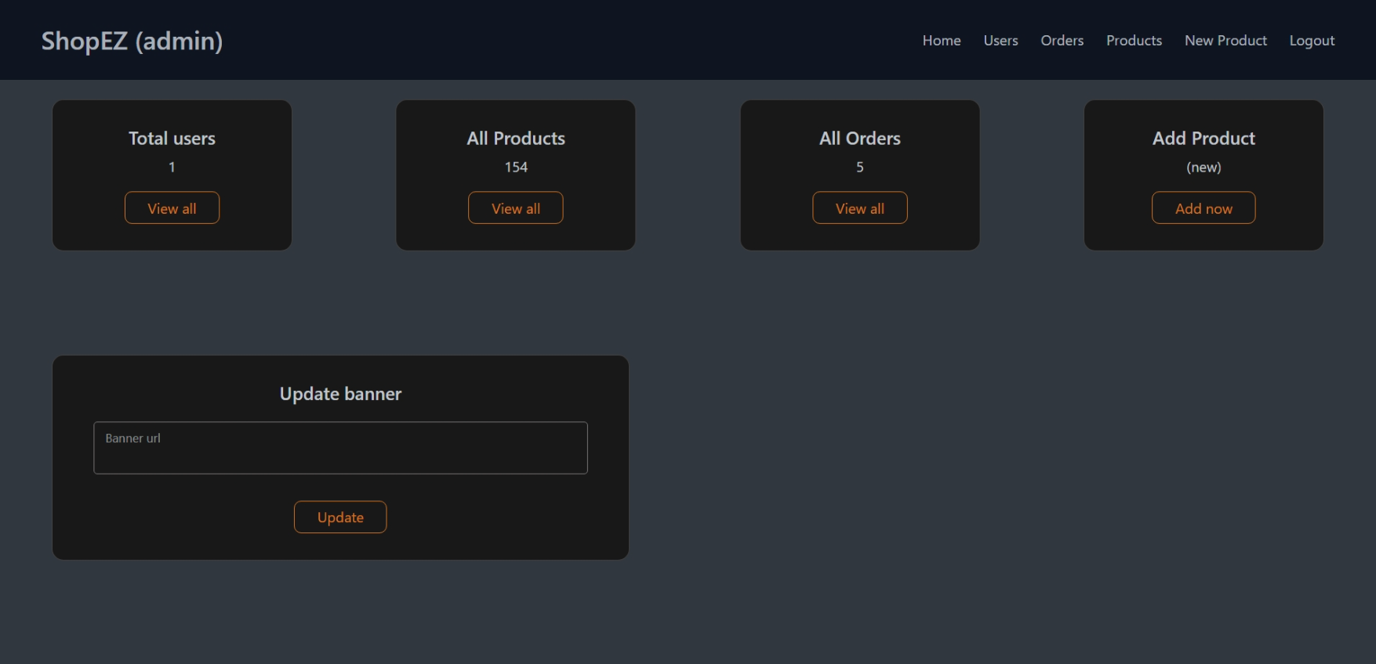

**PRODUCT ADD PAGE:**

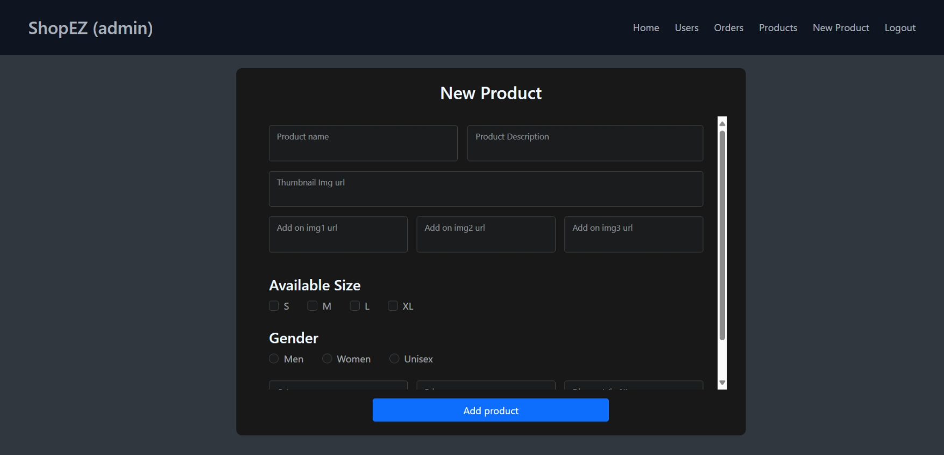

**8. ADVANTAGES & DISADVANTAGES**

**Advantages:**

* Supports small/local sellers
* Cost-effective, no coding required
* Mobile-friendly and fast
* Builds buyer trust through verified sellers

**Disadvantages:**

* Requires internet connection
* Limited adoption by non-tech-savvy users
* Payment and logistics integration may need upgrades

**9. CONCLUSION**

ShopEZ provides a complete solution for small business owners to sell products online easily, while giving customers a smooth and secure shopping experience. It eliminates digital entry barriers, supports local commerce, and encourages inclusive digital growth.

**10. FUTURE SCOPE**

* Mobile app using React Native
* Multi-language and regional currency support
* Seller analytics dashboard
* Delivery tracking integration
* AI-powered product recommendations

**11. APPENDIX**

**Source Code:**

<https://github.com/YalakaturiNarendra/DocSpot-MERN>